FORM 1

General Pre-application Advice Form

Please read and tick one of the following options. We will be unable to accept your application without this.

I consent for my data to be processed and stored in accordance with the Data Protection Act 2018, I understand that the information submitted on this form may be made publicly available or shared with third-parties as necessary (we will never share your information for marketing purposes).

I do not want my data to be made publicly available and have provided the following reason(s) for wanting my application kept confidential:

Please note that if a Freedom of Information or Environmental Information Regulations Request is received that involves the site(s) listed on the application, the Council will have the final decision over whether the data provided can and / or will be released.

Please ensure that the correct fee has been paid and you complete this form in full (relevant parts) and return it to:

Planning Control
Oadby & Wigston Borough Council
Brocks Hill Council Offices
Washbrook Lane
Oadby
Leicester
LE2 5JJ

Or via email to planning@oadby-wigston.gov.uk

Please note that your enquiry will not be assessed until the correct fee has been received

Applicant contact details

Name:

Address:

Post Code:

Telephone No:

Email Address:

Proposal details
Site address to which this enquiry relates:

Full description of proposed works (The more details provided the more informed the response will be):

Dimensions of proposal (include max. length, width and height):

Is the proposed work an extension to an existing building?

Will there to be any internal alterations to an existing building?

Distance of proposed work to nearest boundary:

Proposal site history

Have any previous extensions / buildings / structures been erected at the site since it was originally brought into use? (include all changes):

When was the work carried out?

Vehicle access & demolition details
Will the development require alterations to an existing vehicle access?

Does the proposal require the demolition of any existing buildings?

Please attach a detailed sketch plan showing the position of the proposed development in relation to the property, adjacent properties and the highway (see example below)
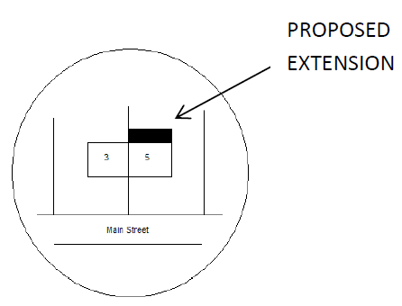

Please attach any additional information you feel may assist us in dealing with your enquiry.

Signature:

Date:

