 | 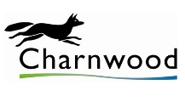 | 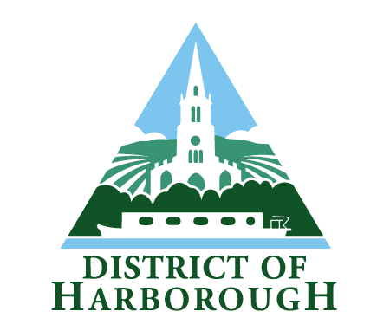 | 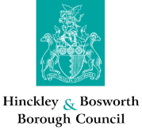 |  |  | 

APPOINTMENT OF INDEPENDENT PERSONS

Blaby District Council, Charnwood Borough Council, Harborough District Council, Hinckley & Bosworth Borough Council, Melton Borough Council, North West Leicestershire District Council and Oadby & Wigston Borough Council (the ‘Councils’) are looking to appoint a number of ‘Independent Persons’ to support them in promoting and maintaining high standards of conduct amongst their elected members. Under the Localism Act 2011, the Councils have each adopted a Members’ Code of Conduct, which reflects the Nolan Principles of Public Life and sets out the standards that elected members are expected to adhere to.

The role of an Independent Person will be as set out in the ‘Role Description’ and will involve giving views on complaints where there is an allegation that a member has failed to comply with the Code of Conduct, as well as participating in misconduct hearings, as required. Complaints may also involve issues relating to parish and town councils in the relevant areas.

Working hours will generally be flexible but there may be a requirement to attend meetings during the day and in the evening, and to be available for telephone/email consultation, sometimes at short notice.

The appointment will be for a fixed term of 4 years to commence from May 2025 onwards. The role is not salaried but travel and subsistence allowances will be payable in accordance with each Council’s applicable rates and training will be provided.

Please note that anyone who is or has been an elected/co-opted member or officer of any of the Councils during the last five years, or its Parish Councils, or who is a relative or close friend of such persons cannot be appointed.

Click here to view the information pack and apply pack
https://www.oadby-wigston.gov.uk/pages/job_vacancies

Please email your completed application FAO David Gill to legal@oadby-wigston.gov.uk

If you would like further information on the role please contact David Gill on 0116 257 2626

The closing date for applications is 3 March 2025.

